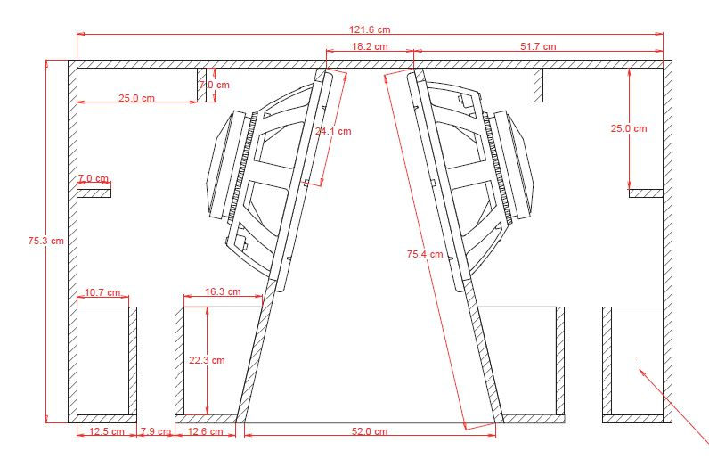
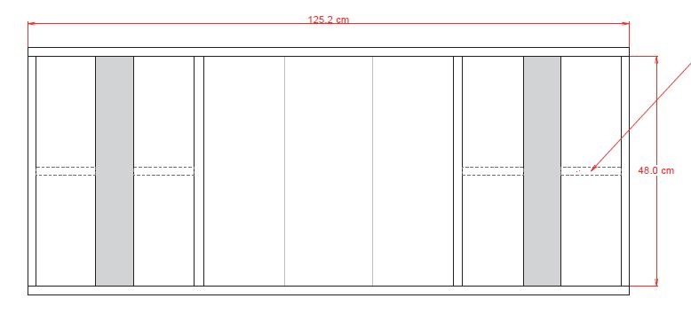
79.76
11.93
33.91
4.59
16.39
4.59
49.39
7.02
8.2
5.2
8.26
13.63
10.69
34.11
15.81
50.21
16.4
82.12
31.48

